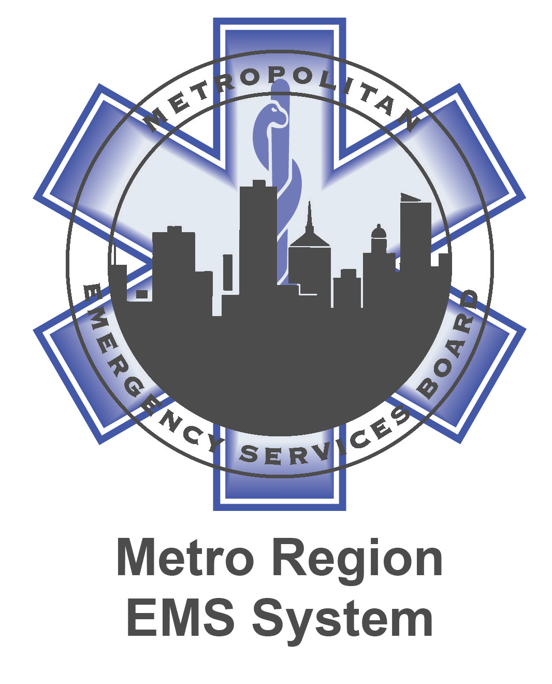
FY2022-2023 MESB-Metro Region EMS Work Plan
Goal Area and Title of Goal/Objective | Short Description of Goal/Objective
Provide training and workshops on current EMS topics or issues to EMS providers in the Metro Region, based on input from the Metro Region EMS System committees and board. Enhance the knowledge and skills of EMS providers and leaders. Use education to bolster relationships with other first responder disciplines and promote public safety responder integration with the EMS system.
Personnel Education and Training
The National Association of Emergency Medical Technicians’ (NAEMT) Advanced Medical Life Support (AMLS) course is the most comprehensive EMS continuing education course. Endorsed by the National Association of EMS Physicians, AMLS emphasizes the use of the AMLS Assessment Pathway, a systematic tool for assessing and managing common medical conditions with urgent accuracy. It provides an in-depth study of the typical medical emergencies that affect the adult patient | Provide EMS personnel Advanced Medical Life Support (AMLS) training emphasis/objectives: The student will learn the Advanced Medical Life Support curriculum's emphasis on the utilization of the AMLS Assessment Pathway, a systematic tool for assessing and managing common medical conditions with urgent accuracy. It provides an in-depth study of the typical medical emergencies that affect the adult patient. The course also evaluates situational and environmental factors affecting patient care. The course also evaluates situational and environmental factors affecting patient care. AMLS is accredited by CAPCE. It is recognized by the National Registry of Emergency Medical Technicians (NREMT) and by the Continuing Education Certification Board for Emergency Medical Services (CECBEMS). AMLS is appropriate for paramedics, nurses, nurse practitioners, physician assistants, nurse anesthetists and physicians.
Action oriented leadership is based on the simple reality that everything one does is a blend of task, process, and people. Each of us – from highest level leader to individual contributor – finds themselves executing tasks, working on or within processes, and interacting with other people throughout the day. Execution, management, and leadership have evolved over time as the disciplines that study and improve how one works in each of these domains. | Provide EMS Leadership training emphasis/objectives: Students will complete the Metro Region EMS Leadership program, a self-paced online hybrid program with twelve (12) course/modules:  Course 1: Foundation: Six Dimensions of Human Action  Course 2: Achieving High Performance Leadership  Course 3: Optimizing Team Performance  Course 4: Sharpening Your Trust Edge  Course 5: Case Study Practice  Course 6: Problem Solving: Beyond Symptoms to Root Causes: Part one  Course 7: Problem Solving: Beyond Symptoms to Root Causes: Part two  Course 8: Motivation & Training  Course 9: Change: Possibilities, Resistance, & Dissatisfaction  Course 10: Practice Framing and Resolving Case Studies  Course 11: Metaphors  Course 12: Presentations and wrap up
Recently, “clinical documentation was developed to track a patient's condition and communicate the author's actions and thoughts to other members of the care team. Over time, other stakeholders have placed additional requirements on the clinical documentation process for purposes other than direct care of the patient. More recently, new information technologies, such as electronic health record (EHR) systems, have led to further changes in the clinical documentation process. | Provide EMS Documentation Specialist training emphasis/objectives: The quality of the course material creates a high level of motivation to improve documentation performance. The course provides a solid platform for any QA committee members to conduct their reviews. The class covers documentation framework, fundamentals, special situations, narrative improvement, CMS compliance, medical necessity and signature requirements all designed to protect providers and agencies "(including medical directors).”
The purpose of this course is to teach a new integrated practice to first responders in a hostile event situation where there are viable victims to reduce morbidity and mortality. The 3ECHO response model is an integrated practice for first responders that move beyond the separation of law enforcement and rescue/medical personnel during active shooter, post blast response, and other hostile events. | 3ECHO Hostile Event Response training emphasis/objectives: Students will learn to attain the primary objectives in the response phase of an active shooter, a bomb incident or a complex organized attack such as identify and neutralize the threat, assess number of casualties, and the integration of disciplines into Rescue Taskforces (RTFs) to be completed as soon as possible during an event response with the goal of providing the ability to rescue viable victims while the response to the hostile event is ongoing and risk to all responders is mitigated.
Physical and sexual assaults on EMS responders when on-duty is not uncommon. Developing skills and techniques to remain centered and focused during any verbal or physical hostile circumstance can de-escalate the situation and prevent on-duty injuries and deaths. Verbal 'conflict management' involves using body language, posture, tone of voice, and well-chosen words as a means for calming a potentially volatile situation before it manifests into a physical violence. | De-escalation Classes emphasis/objectives: It is important that the caregiver maintain self-control to help others control themselves. Students will be trained how to constantly observe patient behavior, so the responder will be able to detect agitation and intervene in a timely fashion, avoiding physical confrontation and the physical restraints that are its usual consequence. To make this outcome possible, the EMS provider will learn to recognize signs of agitation and escalation; should practice presenting themselves as a calm, caring professional' and should maintain poise even when facing a potentially violent patient. The responder will learn how to remain open-minded, knowing that patients frequently react to assumptions made about them, and use the information acquired to find acceptable alternatives to aggression. These alternatives should be presented to the patient, making the choices clear, yet allowing the dignity of choice. Every effort should be made to provide opportunity for patients to be in control of their own behavior. Physical confrontation should always be a last resort, and one used only when there is a clear danger of immediate physical harm to a patient or staff member.

The Ambulance Strike Team Leader (ASTL) must have the capability and experience to manage, coordinate, and direct the actions of the Ambulance Strike Team (AST) at a wide variety of emergency situations. AST assignments may include but are not limited to evacuation assistance, incident rehab, emergency call response, inter-facility transports, on-scene stand-by, search and rescue support, vaccination clinics, hospital, shelter staffing or primary healthcare provider at evacuation centers. | Provide Ambulance Strike Team Leader (ASTL) training emphasis/objectives:  Students will be trained to be an ASTL who ensures readiness of self and AST members for assignments; ensures staff availability, qualifications, and capabilities of resources to complete assignment; understands organization structure, reporting procedures, and chain of command within the ICS structure; understand and comply with ICS and NIMS concepts and principles; supervise the operational deployment of the team at the incident, as directed by the on-scene Division/Group Supervisor, or other members of the IMT; provides oversight of the safety and condition of the team, personnel and associated equipment; communicates IAP operational objectives of an incident action plan (IAP) and required resources needed to accomplish the assignment, given a tactical approach from the Operations section, assigned resources, and operational procedures, so that the required resources are identified and communicated to supervisors, assigned resources are allocated and the assignments are carried out, the tactical assignments are carried out, and the results are monitored and communicated to Incident Command.
This course is designed to provide the skills and knowledge needed to perform in the role of Medical Unit Leader (MEDL). Topics include gathering information, organizing the medical unit, supervising the unit, evaluation, documentation, and demobilization. | Medical Unit Leader (MEDL) training emphasis/objectives: Students will be trained to integrate a Medical Unit into an expanding incident. The Medical Unit Leader is primarily responsible for developing the Medical Plan, obtaining medical aid and transportation for injured or ill incident personnel, supporting a COVID or other mass casualty disease outbreaks during the response, and preparing reports and records as well as assist Operations in supplying medical care and assistance to civilian/volunteer casualties at the incident as needed. The MEDL ensures all Incident operations (including any recovery phases) are supported by medical response personnel; understand ICS and local response systems to directly support the efforts of Incident personnel.
The Communications Unit (COMU) plays a critical support role within the Incident Command System (ICS). ICS establishes basic principles, practical tools, and a definitive nomenclature and structure for supporting incident-based emergency response. It has been common knowledge in Incident Management that responders require reliable and sustainable  communications to perform their assigned function effectively and safely. | Communications Unit Leader training emphasis/objectives: Students will be trained to be a Communications Unit Leader (COML) who heads the Communications Unit and is responsible for integrating communications and ensuring that operations are supported by communications. The COML must understand ICS and local response systems to support the efforts of Incident personnel. The COML is tasked with managing the operational and technical aspects of incident communications.
The job of the Liaison Officer (LOFR) during an emergency response is a critical one. It can have a large impact on the efficiency of resource use during the response operations, and on the perception of stakeholders regarding the success or appropriateness of the response activities. Both factors are critical to overall response success. LOFR is responsible to deal with any public entity, namely assisting and cooperating agencies, stakeholder groups, and government officials who have a vested interest and will be expected to provide input into the response process and will expect situation reports from the Incident/Unified Command. | Liaison Officer training emphasis/objectives: Students will be trained on the primary responsibilities of the Liaison Officer that are to effectively coordinate with participating organizations (assisting and cooperating agencies) and stakeholders in support of the incident. The LOFR serves as the primary incident point of contact for Agency Representatives. This course focuses on the LOFR's main tasks: ensures coordination with cooperators and appropriate members of IMT takes place to accomplish incident objectives, efficiently resolve issues, and share issues and concerns; engage assisting and cooperating agencies and Agency Representatives; coordinate with IC, appropriate members of C&G, and cooperators to assess, evaluate the need for, and plan evacuations; maintain situational awareness/incident status with assisting and cooperating agencies and other stakeholders; monitor incident operations to identify current or potential inter-organizational problems; ensure a clear understanding of expectations and timely communication within and across Incident Command Systems (ICS) functional areas and chain of command.

Transportation Coordination-EMS Response Readiness
The core mission of the Metro Region EMS System is the commitment to strive for competence, commitment, cooperation, and regional EMS coordination in order to provide an effective and efficient regional EMS response in the wake of any disaster through ongoing collaboration with state, county, and local emergency management, public safety, public health and healthcare provider agencies. This plan calls for ensuring readiness and capabilities of the Metro Region EMS System to provide EMS surge capacity capabilities upon request to the metropolitan region, the State of Minnesota and other state or federal jurisdictions. Maintain the capability to support and coordinate with any other MN EMS regional system response strategy for EMS surge capacity through continued development of regional components of MN Ambulance Strike Team (MNAST) that includes supporting and maintaining the Major Incident Response (MIR) bus and other logistical equipment. Maintain support of the EMSRB emergency operations and coordination with the MN EOC (statewide EMS MAC). Provide a real-time, reliable system for EMS resource allocation during mass casualty incidents and large scale, multi-jurisdictional events. | Provide workshops and seminars in the areas of incident management, medical surge and emergency preparedness for EMS provider agencies that comply within state and federal guidelines such as NIMS-ICS structure with state, county, and local emergency management, public safety, public health, and healthcare provider agencies.
 | Provide training on regional response and surge plans.
 | Maintain collaborative participation with regional MNAST participants, county EMS councils and emergency management directors, MN EMSRB, MN Department of Health (MDH), Regional Healthcare Coalitions, the metro Regional Hospital Resource Coordination Center, the MN Metro Regional Trauma Advisory Council (MMRTAC) and emergency preparedness partners.
 | Provide one-stop emergency notification process for EMS surge and MNAST requests.
Public Safety Agency Cooperation
The most feared mass casualty incidents (MCIs) are those that are caused by a hostile event. In light of recent disasters, an overwhelming initial coordinated public safety response is mandatory in order to mitigate tragic loss of life and human suffering. In order to be successful and efficient, such a response requires planning, equipment and trained personnel. | Offer Incident Command System (ICS) training to EMS, fire, and law enforcement personnel.
 | Participate in the metro Healthcare Multi Agency Coordination Center activities.
All public safety responders are susceptible to stress-related mental disorders such as acute stress disorder (ASD) and posttraumatic stress disorder (PTSD). All first responders should have ready access to a team of trained individuals who have working knowledge of trauma, common reactions to trauma, PTSD, and other stress-related mental issues, in a peer-driven program that offers post-incident crisis intervention. | Enhance the well-being of EMS providers through instruction and funding of peer support(er) trainings and critical incident stress management (CISM).  Collaborate with other regional EMS programs to support the development and sustainability of CISM teams.

Communications Systems Maintenance and Development
Ensure EMS participation, compliance, and exercise within the scope of the regional tactical interoperability communications plan (TICP) and regional and statewide ARMER system standards. | Exercise and train EMS regional communication plans during planned events to be prepared to utilize plans during real incidents and events.
Maintain the EMS/MNAST communication assets. | Maintain fleet maps to follow state and regional standards; maintain and service radio cache as needed.
Support regional COMU personnel during events and deployments. | Provide COML training for taskbook/credentialing.
Public Involvement
Promote public and governmental awareness of health and safety-conscious lifestyles through a public education campaign that targets the reduction in the risks of illness or injury and/or promotes safer behavior as well as promotes the essential roles EMS plays in the region.  Identify public education initiatives addressing needs identified by the Metro Region EMS providers or gaps/needs gleaned from community health mapping and assessments. | Ensure metro region EMS website is current through regular updates and additional postings of new information to site.
 | Support public education campaigns by distributing general health, emergency medical care and personal-family preparedness materials to EMS providers and collaborative partners for public distribution.
Health Care Facilities Involvement
By action of the EMS TOC and the MESB, the Metro Region EMS System (MREMSS) acts as the regional EMS representative of the EMS community within the Metro Region Healthcare Coalition and sits on the Steering Committee. Also, the MREMSS is the MDH contracted host of the MN Metropolitan Regional Trauma Advisory Committee (MMRTAC)and provides a coordinator to the committee as well as provides administrative assistance to the committee. | Support and maintain the MMRTAC operations.
 | Participate within the regional Healthcare Coalition (includes Emergency Management, Public Health, Hospitals and Hospital Systems, Unaffiliated Clinics, and Long-Term Care) and represent metro EMS agencies within MDH statewide Hospital Preparedness Program (HPP).
System Management
Ensure Metro Region EMS System remains operational. | Support as necessary Metro Region EMS System transport agencies.
Equipment and Vehicle Purchases (Minn. Stat. §169.686 funds only)
 | Maintain and upgrade as necessary regional EMS equipment including the regional MIR bus.
Replace Metro Region EMS ARMER Radio cache | The current radio cache is obsolete and not supported by Motorola.

