

Minnesota Metropolitan Regional Trauma Advisory Committee

C-Spine Injury Resource

PURPOSE
Provide a resource with a variety of geriatric care options for any level of Trauma Center related to cervical spine injuries. This resource includes multiple strategies on how to manage/care for geriatric trauma patients.

CONTENTS
- Injury Types
- When to Place a Collar
- Types of Collars
- Fitting Collars
- Skin Integrity
- Mobility/ADL considerations
- Nutrition
- Risks/Nursing Education
- Transfer Indications
- Patient/Family Education
- Resources

Injury Types
Epidemiology:
Motor vehicle related crashes account for almost half of all spinal injuries, many of which are also associated with speeding, alcohol intoxication, and failure to use restraints. Rollover type motor vehicle crashes are at increased risk of cervical spine injury. In addition, injuries from violent trauma, falls in older adults, and sports injuries are other common causes.
Anatomy:
The spine consists of 33 vertebrae: 7 cervical, 12 thoracic, 5 lumbar, 5 sacral (fused), and 4 coccygeal(fused). These are separated by intervertebral disks and connected by ligaments. The vertebral column provides support for the body and protects the spinal cord.
The cervical spine is the most commonly injured part of the spinal column. Within the cervical spine, the most common sites of injury are around C2 or the region of C5,6 and 7.
A great amount of force is necessary to damage the thoracic spine in a healthy adult, more common in older adults with bone disease.
The second most commonly injured region is the thoracolumbar junction, particularly between T11 and L4.
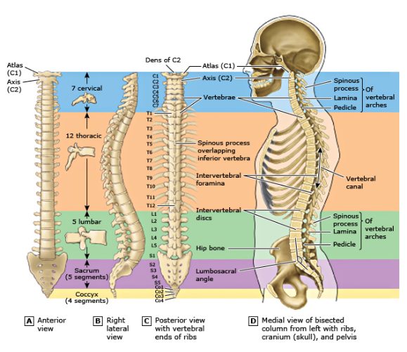
Mechanisms of Injury:
Injury to the spinal column may result in spinal cord or brain injury through several mechanisms.
- Transection – this can occur from penetrating or massive blunt trauma resulting in transection of all or part of the spinal cord or from bony fragments that are displaced into the spinal canal.
- Compression – these typically result from an axial load or a flexion/hyperextension mechanism.
- Contusion – these can occur from dislocations, subluxation or fracture fragments.
- Vascular compromise- there should be a higher index of suspicion for vascular damage if the clinical neurologic deficit and the known level of spinal cord injury does not match.
Cervical Spine Injuries:
- Atlanto-occipital dislocation – this occurs typically with a flexion injury and involves the atlas (C1) and the axis (C2). This can cause a dislocation with or without an associated odontoid fracture. The top of the spine and the base of the skull are involved.
- Atlanto-axial dislocation – this is unstable and is caused by a flexion-rotation mechanism.
- C1 Fractures
  - C1 Burst (Jefferson) – This is highly unstable and occurs when vertical compression force is transmitted through the base of the skull resulting in fractures of the anterior and posterior arches of C1, with or without disruption of the transverse ligament.
  - Posterior arch – compression of the posterior elements between the occiput and spinous process of C2. These are mechanically stable but can be dangerous based on the location near the spinal cord.
- C2 Fractures
  - Hangman’s fracture- this is traumatic spondylolysis of C2 and is an unstable injury that occurs when the cerviocranium (skull, atlas, and axis functioning at a unit) is thrown into extreme hyperextension because of abrupt deceleration. Bilateral pedicle fractures of the axis can occur. It is unstable; however, the spinal cord damage is usually minimal because the AP diameter of the neural canal is greatest at C2.
  - Odontoid fractures – forceful flexion or extension of the head in an anterior-posterior orientation can occur often with falls and can result in a fracture of the odontoid process, also called the dens. There are three types, based on where the odontoid process is fractured. Type I is a fracture at the tip and is stable. Type II and III are mechanically unstable, but again, the neural canal is wide, thus do not often result in spinal cord injury. These are often managed with a rigid cervical collar such as the Aspen collar or Miami J collar.
  - Flexion or extension teardrop fractures – these are highly unstable fractures resulting from severe flexion / extension. There are often ligamentous injuries associated with these. These are most seen at C2 but also can be seen at C5 to 7 with diving accidents. Central cord syndrome is commonly seen with this injury.
Additional fractures seen throughout the cervical spine:
- Compression fractures – Wedge or anterior compression fractures account for 50-70 percent of injuries. They result in compression due to an axial load applied in flexion. Those that do not disrupt the posterior ligament are stable. If there is severe compression (>50% of vertebral height), significant kyphosis (> 30 degrees), a rotational component to the injury, or fractures at multiple levels, this could result in spinal instability.
- Burst fractures – these comprise about 14% of all injuries and are caused by compressive forces / axial load that fractures the vertebral endplate and pressure from the nucleus pulposus. Spinal cord injury from retropulsion of bony fragments into the spinal canal can occur.
- Flexion – distraction injuries (lap belt injuries) – these injuries occur when patients are only wearing a lap belt (no chest restraint) during a motor vehicle crash. Neurologic deficits are rare, however associated intraabdominal injuries such as small and large intestinal perforations are more common.
- Spinous process and transverse process fractures – these are fractures of the tips of the vertebrae (spinous process or transverse process) these are not unstable fractures and do not require a brace or stabilization.

WHEN TO PLACE A COLLAR
- C-Collar Application
  - Injury witnessed/suspected with:
    - Paresthesia or weakness in extremities
    - Altered Mental Status or intoxication
    - Neck pain or tenderness to palpation
  - Dangerous Mechanism of Injury (MOI)
    - Fall from >3 ft/5 stairs
    - An axial load to the head
    - Motor vehicle collision (MVC)
      - At high speed (>60mph)
      - Rollover
      - Ejection
    - Motorized recreation vehicle collision (including scooter)
  - Age greater than 65
  - Distracting injury
  - Complaint of Dizziness – use high suspicion for history of falls
  - Nursing judgement
  - **Visual pathway in resources section below**

TYPES OF COLLARS
Stifneck Rigid Collar:
- Prehospital or short-term option for cervical spine immobilization
- One piece with sizes for adult and pediatric patients.
- It can lead to skin breakdown over bony prominences if in place for an extended period.

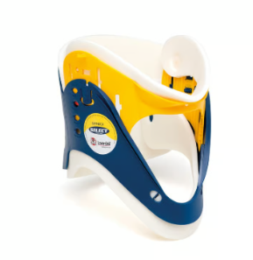
Philadelphia Collar:
- Short-term for cervical spine immobilization
- Two pieces, made from foam
- Multiple sizes available for adults and pediatric patients
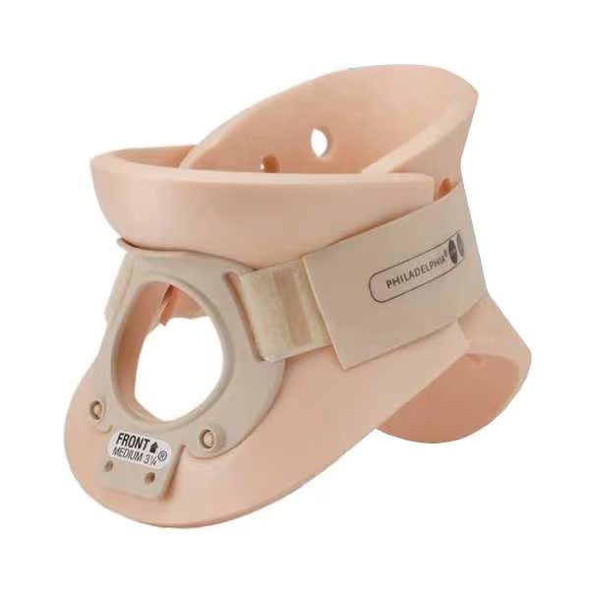

Longer term rigid collars:
Aspen Rigid Collar:
- Utilized for patients who have factors limiting them from having their cervical spines cleared in a timely manner and for those requiring longer term cervical immobilization.
- Two-piece collar with replacement padding ideal for patients needing long term wear.
- Multiple sizes are available for adult and pediatric patients.
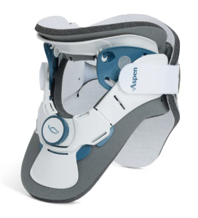
Miami J Rigid Collar:
- Utilized for patients who have factors limiting them from having their cervical spines cleared in a timely manner and for those requiring longer term cervical immobilization.
- Two-piece collar with replacement padding ideal for patients needing long term wear.
- Multiple sizes are available for adult and pediatric patients
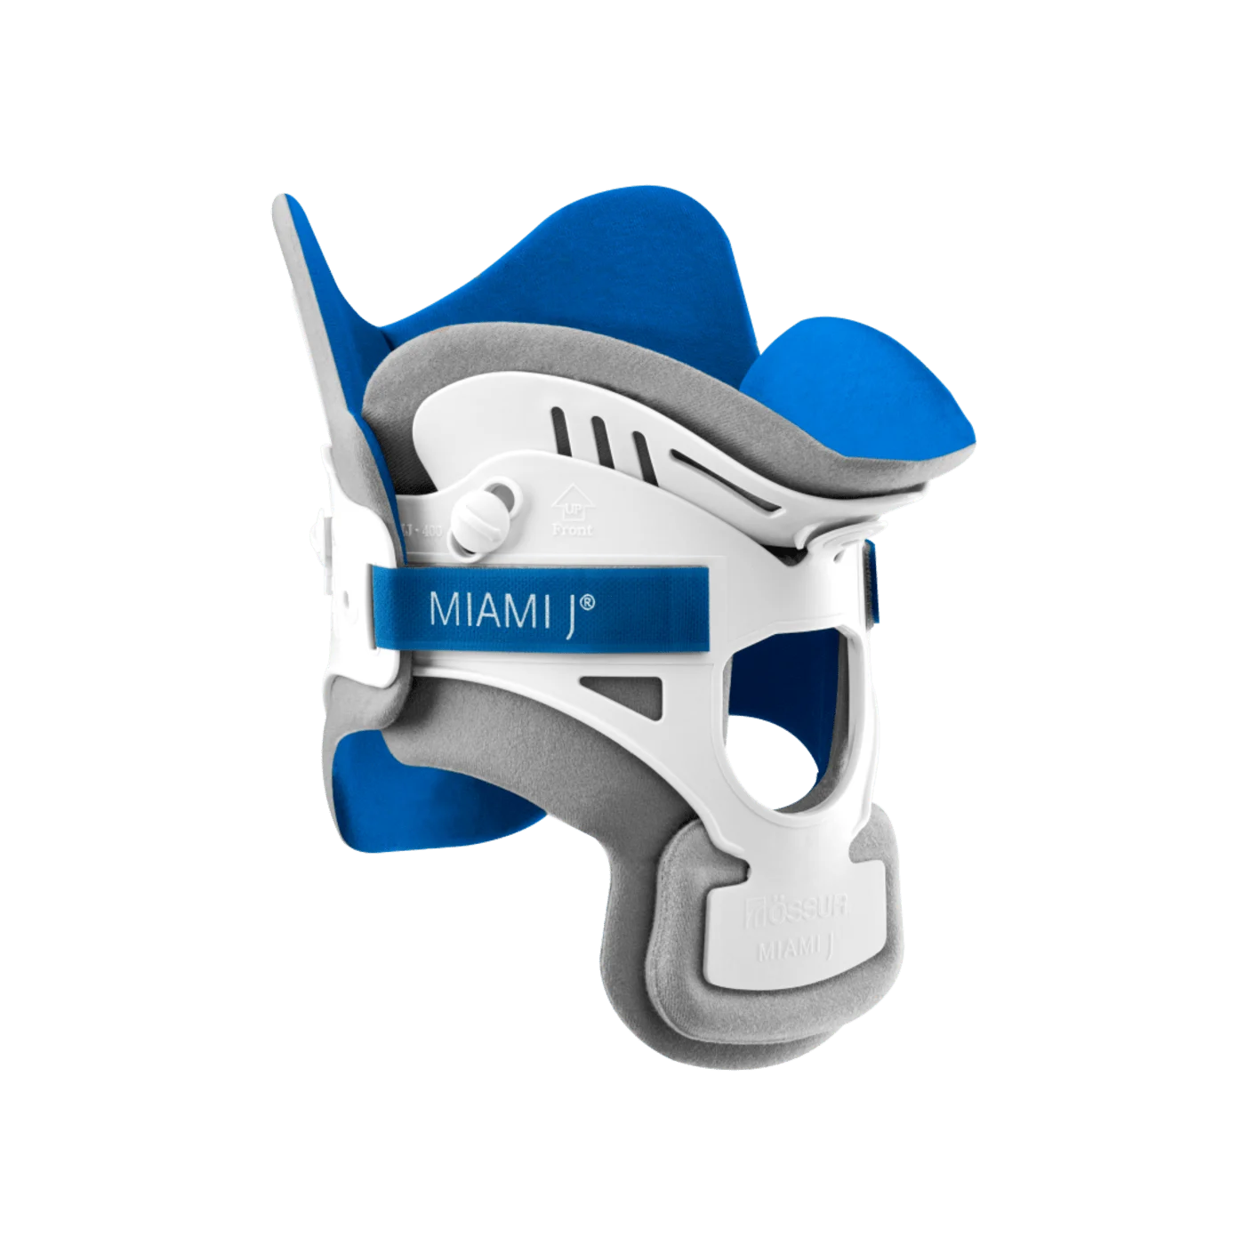
FITTING COLLARS
- In case of actual or suspected spinal cord injury, the patient must be fitted with the collar in a flat, supine position by (2) people. No pillows should be behind the head.
- To apply collar in supine position, follow these six steps:
  - Pre-form the collar
  - Position the back panel
  - Position the front panel
  - Adjust the height
  - Tighten the collar (if needed)
  - Check the fit
    - Reassess the fit and alignment with any position changes
    - Check that ears are aligned with the shoulders & head is in neutral alignment
    - Chin should be centered comfortably in the chin piece
    - Nose and chin should align vertically through the center of the collar
    - Velcro straps should be aligned and overlapping
    - Verify patient can breathe and swallow comfortably
- ** See Resources for more detailed instructions**
Fitting a Philadelphia Collar
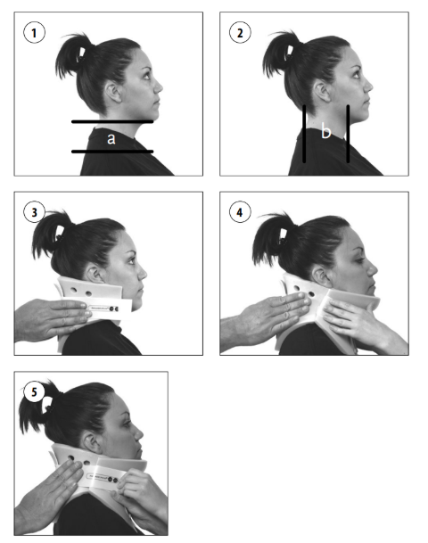
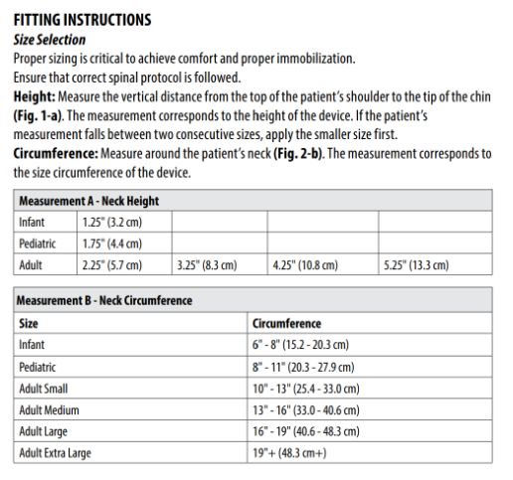

Fitting a Miami J
https://media.ossur.com/ossur-dam/image/upload/pi-documents-global/Miami_J_1067_001_10.pdf
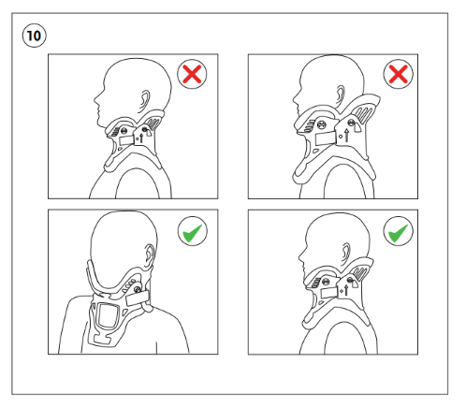
Final Fitting Checklist A properly applied device will look like Fig. 10.
  - Collar extends from mandible to just below sternal notch.
  - Chin is centered comfortably in Chin Support. Chin should not extend over edge of Sorbatex™ pad, nor fall inside collar.
  - Straps are aligned to the Hook landing area and are an equal length.
  - Sides of Back should overlap sides of Front.
  - Front of collar angled up toward ears. Lower plastic edge should not be resting on patient´s clavicles nor digging into trapezius.
  - No plastic touching skin. Sorbatex™ pads extend beyond all plastic edges.
  - No slack or gaps in any of the straps.
  - Tracheal opening and posterior vent are midline.
  - Collar sits away from the neck. There should be a “finger” gap between the tracheal opening and the neck.

Aspen Collar
https://www.aspenmp.com/cdn/shop/files/LB0083C_ROW_VRTX_Cervical_Collar_TX_Collar_MP_Collar_16_Lang_IFU-MDR_03-10-23_Final_9fd4c517-4b84-4fec-83c9-e8d54475833d.pdf?v=9352390966525026153
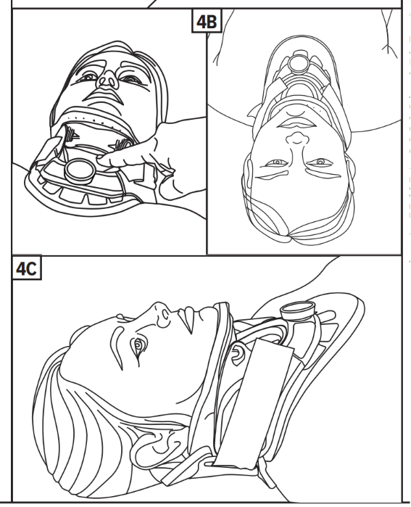
Check the Fit:
- Chin Dots Hidden? The chin piece plastic should be flush with the end of the chin, hiding the “chin-dots” indicator on the chin pad.
- Height Correct? Collar height is correct when it supports the patient’s head in neutral alignment.
- Collar Snug? Evenly tighten and re-tighten the straps for a secure fit.
- Airway Clear? Check that the back of the chin piece does not contact the throat. If it does, release the strap and reposition the chin piece. Recheck to ensure the airway is clear.
- The patient often changes position, so it may be desirable to readjust the height and the back panel straps.

SKIN INTEGRITY
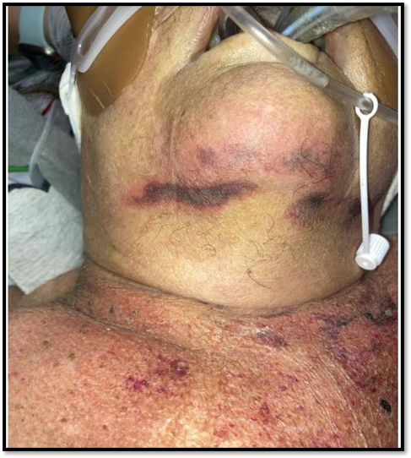
- Assess skin Per Hospital Guidelines
  - Recommended: Every 2 hr & PRN
    - With log rolling and/or repositioning patient
    - Assess alignment and any new or changed pressure points with repositioning
  - Recommended: Every 4 hrs (ICU) & 8 hrs (Med/Surg) & PRN
    - Inspect and palpate for any changes in skin condition
    - Remove any foam pads to assess underneath the collar
- Pad Changes for Cervical Collar
  - Two sets of cervical pads should be available for patients to rotate
  - An extra set of pads comes in the c-collar package – don't throw them away!
  - Wash pads with soap and water, squeeze out excess water, and lay flat to dry (6-8 hours)
  - Replace with a clean, dry set (do not apply wet pads to a cervical collar)
  - Recommended to remove one foam pad and replace with its matching clean pad at a time to ensure pads are replaced in correct location on collar
  - Consider adding foam or silicone dressings to pressure points under the collar

- Documentation
  - Document skin condition and c-collar management when completed
  - Document pad care/changes at a minimum every 24 hours
  - Provide patient/caregiver education on:
    - When collar needs to be worn per MD order
    - Proper cervical alignment
    - Skin care
    - Pad cleaning

Skin Considerations
Changing from a hard collar (e.g. hard foam collar or EMS collar) to a orthotic device (e.g. Aspen, Miami J) within 24 hours or ASAP.
As soon as possible while in a c-collar
- Upon arrival, thoroughly assess and document skin concerns.
- Pad pressure points where collar makes contact with skin:
  - Occiput (especially while patient is flat bedrest)
  - Chin
  - Upper shoulders/trapezius region
  - Chest
- Use silicone foam dressing to provide padding to pressure points (e.g. Mepilex) anywhere hard plastic may come into direct pressure on the skin. See image below:

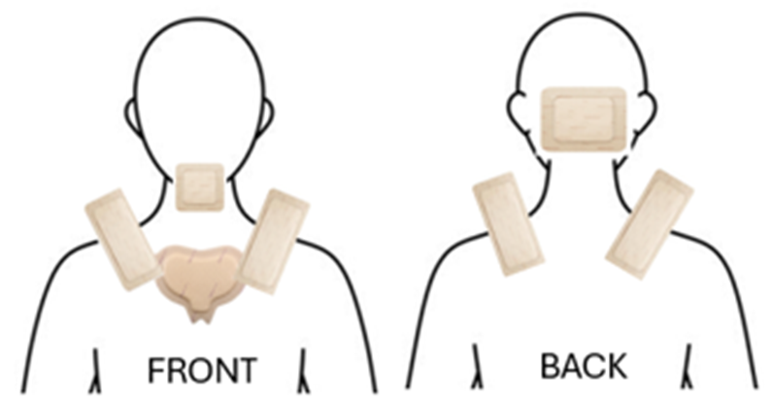

Collar Skin Assessment
- Skin should be assessed every 8 hours & PRN
- Look under silicone dressings. Change if soiled or not lying smoothly.
- Collar pads should be changed & cleaned at least once a day & PRN, if moist or soiled.
- Pressure, moisture, heat, and dirt can all lead to skin breakdown
Additional Considerations
- Keep the skin clean and dry
- Keep the pads clean, dry, and free of debris and secretions.
- If the patient requesting a pillow for comfort, place under the shoulder blades to maintain alignment. If it is placed just under the head, it flexes the neck forward displacing alignment and adding pressure on the chin.
- If there is matted hair- untangle or shave the hair off.
- Trim full beards to decrease pressure. Shave hair growth if able.
- If more pads are needed or there is a concern with the fit of the brace, call Orthotist to reassess.
- If redness or skin injury develops, follow hospital skin injury process.
Safe C-Collar Maintenance
Cleaning & Skin Care Cervical spine immobilization should not be compromised for skin/wound care. To maintain the patient’s head, neck and airway in proper alignment, at least three people are required.
- While maintaining c-spine precautions, remove the front of the brace. Peel the soiled, blue pads off. Look carefully at the shape as you remove them so that you can reposition the clean pads properly. The pads are attached with Velcro. Assess Mepilex dressing.
- While holding c-spine precautions, turn the patient to their side and remove the back part of the brace. Again peel the soiled, blue pads off.
- Wipe the plastic brace and back, clean thoroughly with mild soap and water. Clean the patient’s neck and back while assessing skin. Make sure the skin is completely dry.
- Attach the replacement pads. Reapply brace.
- Wash the pads with mild soap and water. DO NOT use bleach or harsh detergents. Thoroughly rinse the pads with clean water. Lay the pads out flat to air dry.

MOBILITY CONSIDERATIONS
Basic Considerations for Mobility
- Screen for mobility limitations and assurance of early, frequent, and safe mobility.
- Liberal consultation of PT and OT is recommended.
  - All therapy progress notes include the following: Discharge Recommendations, Barrier to Discharge, Home Needs Upon Discharge, Follow-up, Equipment Status and Recommendations, and PM&R Recommendations.
Screening of Elderly Patients
- Baseline functional status evaluation. Understanding the usual health, home environment, and baseline independence to better identify barriers to discharge and optimize functional status.
- Cognitive evaluation: Consult OT for further evaluation as indicated.
- Assessment of vision, hearing, cognition, and functional level (baseline vs current).
- All patients are assessed for fall-risk using the hospital’s selected screening tool (e.g. Morse Fall Scale). Nursing completes fall prevention assessment every shift and applies appropriate interventions

Physical Therapy, Mobility & ADLS
Imaging and Activity Orders
- A provider should assess neurologic changes (numbness, weakness, pain) when raising HOB for the first time
- Obtain appropriate imaging to assess for C-spine stability with c-collar prior to any elevated head-of-bed or out-of-bed activity
  - E.g. Upright X-rays after fitted for C-collar
- Obtain proper Activity Orders that reflect current permitted activity.
Spinal Precautions when Ambulating
- Ensure collar is properly fitted & padded
- Restrict activities which involve ‘pushing’ or ‘pulling’, or twisting / bending of the neck.
- Continuously assess for neurologic changes while ambulating such as numbness, weakness, gait disturbances
- Do not raise allow patient to raise arms higher than shoulder level

Mobility/ADL Patient Education
Until your doctor says it’s ok:
- Do not lift > 5-10 pounds
- Do not raise your arms higher than shoulder level
- Do not twist or bend your neck any time the collar is off for cares

Grooming Tips
- When brushing your teeth at the sink, it can be helpful to tuck a washcloth between your chin and collar to keep the collar padding dry.
- You will need to lay flat in bed to take the collar off to shave. Place an open towel behind your head before lying down to catch hair that may fall. You may need assistance or to use an electric razor. Do not tilt your head back or turn your head.
- If you have long hair, you may prefer to have your hair out of the brace when putting it on. You may prefer to wear your hair in a ponytail at a height above the back edge of the collar.

Bathing
- If a Philly collar (tan/foam collar) was given to you, you can use this collar when in the shower. Change into this collar lying flat in bed (see “Putting the Collar On” above).
- If you wear your padded collar in the shower, you will need to change to dry pads after you are done showering.
- You may want to wash and dry the skin under the collar when it is removed to change the pads.

NUTRITION
- Things to consider
  - Start multivitamin
  - If patient is consuming 50% of meals, add 2 high protein liquid supplements (examples: Boost, Boost Plus, Boost High Protein, Ensure, Ensure High Protein)
  - If patient is consuming less than 50% of meals, add 3 high protein liquid supplements
  - If patient dislikes high protein supplements, then add high protein food supplements BID for snacks (examples are meat sandwich, yogurt, cheese and crackers)
  - Consider speech therapy(SLP), if available, for swallowing and aspiration risk assessment
- Patients with a C1 and/or C2 fracture are at increased risk of silent aspiration
  - Highly recommended that these patients have a speech therapy evaluation, as silent aspiration can only be ruled out with an instrumental swallow study (such as video swallow study or fiberoptic endoscopic evaluation of swallowing)
- Patients with a C3 through C6 fracture are at increased risk of delayed swallow response and pharyngeal statis due to potential damage to the pharyngeal plexus, which is at the C3 level.
  - If a patient is feeling like there is a lump in their throat or food getting stuck in their throat, recommend a speech therapy evaluation.
- If patients are wearing a cervical collar, the presence of the collar alone should NOT cause pharyngeal dysphagia symptoms, as the collar keeps the neck in a neutral position.
  - The collar may cause some difficulty with chewing due to a reduced jaw range of motion.
- For patients with dysphagia or at increased risk of silent aspiration, thorough oral care mitigates the risk of developing aspiration pneumonia by reducing pathogenic bacteria from the mouth.

TRANSFER INDICATIONS
Per your facility resources and admission/transfer policies.

PATIENT/FAMILY EDUCATION
Why You Need a Cervical Collar
Your doctor has prescribed a cervical collar to protect and support your neck after an injury or surgery. This collar helps keep your neck in the correct position to heal safely. It is important to keep your head and neck as still as possible during recovery.
General Guidelines
- Always wear your collar unless your doctor tells you otherwise.
- Remove the collar only to clean your skin and change pads, while lying flat in bed.
- Avoid driving, heavy lifting, or strenuous activities.
- Follow all instructions from your trauma team or orthotist.
Spinal Motion Restriction (SMR)
The goal of SMR is to minimize movement of the spine to prevent further injury. Always keep your head and neck aligned and still when the collar is off. Movement—even small—can worsen spinal injuries.
Putting On and Taking Off the Collar
You may need help from a caregiver. Gather these supplies:
- Clean collar pads
- Mild soap and warm water
- Washcloth and towel
- Mirror
- Electric shaver (if needed)
Steps:
- Lie flat on your back in bed.
- Keep your head and neck straight and still.
- Undo one side of the collar and gently remove it.
- Wash your face and neck with mild soap and water.
- Rinse and dry your skin thoroughly.
- Check your skin using a mirror. Look for red spots or sores.
- Replace dirty or damp pads. Ensure the white side touches your skin and the gray/green side touches the plastic.
- Reapply the collar: front piece under chin, back piece behind neck, fasten straps evenly.
Skin Care Tips
- Check your skin daily for redness, sores, or irritation.
- Red marks should fade within minutes. If not, contact your trauma team.
- Keep skin clean and dry. Avoid lotions, powders, or oils under the collar.
- Men should be clean-shaven unless they had a beard when fitted.
Preventing Pressure Injuries
- Reposition every 2 hours if bedbound.
- Use pressure-relieving cushions.
- Inspect skin under the collar frequently.
- Pay special attention to the chin, jaw, ears, shoulders, and back of the head.
Neurological Monitoring
Watch for changes in sensation or movement:
- Numbness or tingling
- Weakness
- Loss of coordination
- Difficulty holding objects
Report any of these symptoms to your healthcare provider immediately.
Cleaning the Collar and Pads
- Hand wash pads with mild soap and warm water.
- Rinse well, gently squeeze, and lay flat to dry.
- Do not use a washer or dryer.
- Clean plastic parts with soap and water, then dry with a clean towel.
Pain and Comfort Management
- Use cold packs (not under the collar) for comfort.
- Practice relaxation techniques.
- Ensure proper collar fit to avoid pressure points.
- Ask your provider about pain management options if needed.
Discharge Checklist
Before leaving the hospital or care facility, make sure:
- Collar fit is confirmed
- Skin is intact and healthy
- Pads are clean and dry
- Follow-up appointment is scheduled
- Emergency contact information is provided
When to Call Your Doctor
Call your doctor if you experience:
- Sudden neck or back pain
- Numbness or tingling in arms or legs
- Difficulty fitting the collar properly
When to Call Your Orthotist or Trauma Team
Contact your orthotist or trauma team if:
- You notice pressure sores or red areas that do not go away
- The collar feels too tight or too loose
- You are unsure how to clean or adjust the collar

RESOURCES
Detailed instructions/competency on fitting C-collars

Cervical Collar Application Guide

Pre-Forming the Collar
- Separate the collar by removing the Velcro straps on the back panel from the front of the collar and pre-form by bending or rolling the collar ends in toward the center of the collar.
  - This will help ensure that the collar conforms to the patient’s anatomy, making it more comfortable and providing adequate motion restriction.

Positioning the Back Panel
- One person stands at the head of the bed performing a head hold to maintain a neutral alignment of the cervical spine until the collar has been fully fitted.
- The second person positions the back panel next to the patient’s head between the patient’s ear lobes and trapezius muscle of the shoulder.
  - The Velcro strap should read VISTA right-side up to the person fitting the collar.
- The second person places their hand on the back panel and simultaneously presses down to compress the mattress and slides the back panel behind the patient’s neck until the back panel is positioned correctly, centered behind the patient’s neck.
- Pull the Velcro strap out to the sides and align it between the bottom of the patient’s ear lobe and the top of the trapezius muscle.

Positioning the Front Panel
- Pull the side panels of the front panel apart to open the collar and position the collar so that it is lying flush under the tip of the patient’s chin.
  - The sternal notch should be visible within the access window.
- Allow the collar to rest, then slide the sides of the collar up and over the trapezius muscle.
- Hold the front panel of the collar firmly in place with one hand. With the other hand, push the sides of the front panel up over the shoulder muscles and around the neck toward the ears.
- While holding the front panel with one hand, pull the Velcro straps out and forward to attach them to the front panel.
- Ensure that the patient’s chin is centered on the chin piece and aligned with the dial and the sternal notch.

Adjust the Height of the Collar
- While holding the front panel in place, grasp the dial between your thumb and forefinger and gently pull the dial out to release the lock.
- Maintain the pull on the dial to turn the dial either clockwise to dial up and raise the front section of the chin piece of the collar or counterclockwise to dial down and lower the front section of the chin piece of the collar.
- Dial up until the foam pad on the chin piece begins to compress the patient’s chin.
  - This indicates that the correct height has been achieved.
- Check the green sizing indicator on the side of the front section of the collar to ensure that the collar is aligned in the indicated section.
- Release the dial and it will automatically lock in place.
- Twist the dial without pulling out to ensure the collar is in the locked position.
- Using a finger, feel around the edge of the patient’s jawline to ensure there is not a gap between the patient’s chin and the chin piece.

Tightening the Collar
- To tighten the collar, place one hand on the front of the collar and unattach the Velcro straps one side at a time without releasing the back.
- With your hand or fingers on the side of the collar, form each side panel around the patient’s neck and pull the Velcro straps forward while pulling the Velcro straps down to tighten the collar.
- Repeat the tightening process on the opposite side to conform to the patient’s neck shape.
- Make sure that the side does not get caught on the back panel window and that the front and back panels overlap each other.
- Tighten the other side equally and repeat as needed to ensure a snug, symmetrical fit.

Assess the Fit
- To assess the fit, the collar should be checked from the front and side view:
  - The chin should be centered comfortably on the chin piece.
  - The patient’s nose and chin should be aligned vertically through the center of the collar at the front.
  - The patient’s head should be in neutral alignment (not overextended).
  - Sides of the back piece should overlap sides of the front piece.
  - Velcro straps should be aligned symmetrically.
  - Sternal notch is visible in the front panel window.
  - Both the front and back panels should be centered (chin, dial, and sternal notch are all in alignment).
  - The large openings of the front panel and the back panel should be centered over the neck.
  - Collar should be flush with the skin with no slack or gaps in the collar:
    - Push your finger down past the ear and behind the mandible.
    - Run your finger along the collar toward the chin and then under the sternal aspect of the collar.
    - The chin should be flush with the end and the chin pad should sit under the chin, not sticking out.
    - No plastic parts of the collar should be in contact with the patient’s skin.
- Check that the back of the chin piece is not pressing against the patient’s throat and that they can breathe and swallow comfortably.
- The first person maintains neutral alignment of the head.

Example of Clinical Pathway on Placing C-Collar
